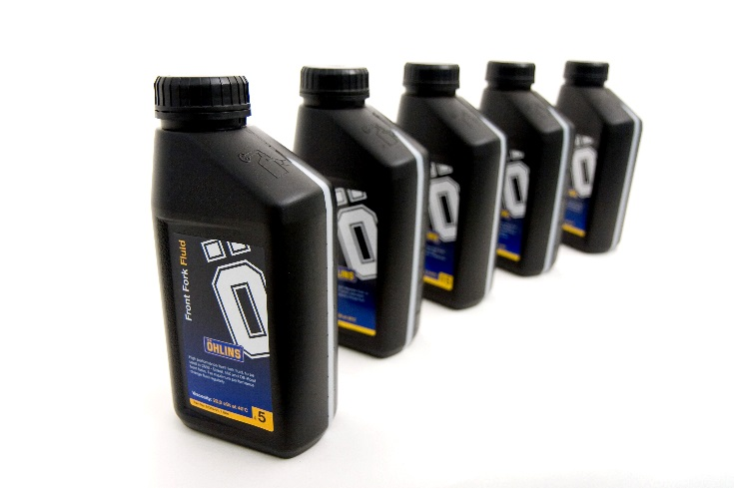WHY ÖHLINS OIL?

Öhlins Racing lubrication fluids are tailor-made for their products. Öhlins engineers oversee that every drawing is scrutinized for each and every product. Based on the results in the combination with the kind of use the shock absorber is tended for, a special lubrication fluid is made to fit like a glove in the system.

Just like in Cinderella, the shoe will only fit one and no one else. The exact same thing can be applied to the insertion of lubrication fluids into Öhlins suspension products. As soon as you change to another fluid or brand the functionality, comfort and performance will be compromised and only luck will separate the ones that don’t feel any difference from those that lose their edge when riding on Öhlins suspension

**THE ART OF LUBRICANTS**

Ever heard of Tribology? It is actually the science of friction, wear and lubrication. The word Tribo comes from the Greek word for rubbing.

It all comes down to 50 some base oils, approximately 300 additives to improve certain features and a total of 650 recipes that together form the huge base of alternatives to find the optimal lubrication fluid for a certain product. The cost to find a perfect match for a recent car model can exceed $2 million and when you think of the speed at which new car models appear on the market today, the price tag for serious oil manufacturers to keep up with a professional series of oils in the assortment becomes very high.

When buying motor oil for your car the price tag differs a lot depending on the brand of the lubricant. But within the Automotive industry the rules and regulations concerning the recipe for oils are rigorous and the accepted base oils and additives are pinpointed to a very high level of detail. If you want to make motor oil for cars and pass the tests you really have to follow the rules.

The same thing cannot be said about the shock absorber area where absolutely no rules and regulations have been drawn up. This is why a serious suspension manufacturer needs a close cooperation with a lubricant specialist. Öhlins has partnered with Statoil which is the third largest crude oil supplier in the world. Today Statoil is a vital part of the R&D phase when designing a new product. When faced with all the potential enemies a lubricant fluid has to fight off and the multitude of areas that Öhlins shock absorbers, front forks and steering dampers work in, you really need a professional lubrication fluid, made from scratch to fit specific purposes.

From Crude to Perfection

Once it has been pumped up, the raw material, called crude oil, is transported to land and distilled to separate the crude oil into different sorts of base products. Often the crude oil in lubrication fluids originates from the so called Sweet Arabian Crude and the chemical process is mainly operated from France and England. In designing our oil, we have to follow all these testing parameters

**TESTING PARAMETERS**

|  |  |
| --- | --- |
| * Friction. Static and dynamic * Viscosity * Viscosity and VI * Temperature fading * Bulk modulus * Corrosion * Oxidation * Water and moisture absorption * Color * Allergenic properties * Sealing performance * Wear and lubrication properties * Density by temperature | * Gas absorption * Flame point * Pour point * Boil point * Air release. The ability for non- solved air bubbles to get released. * Hyperbar hydraulics * Smell * Swelling of rubber components * Shear stability * Foaming properties * Sensitivity to cavitation |

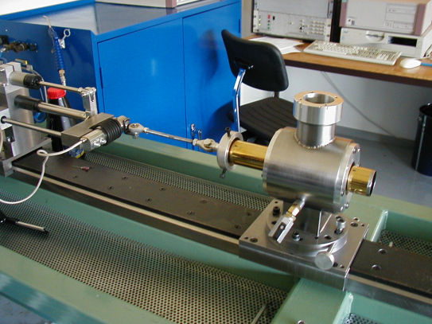**Friction rig static measurements**

* For oil test
* For bushing test
* For seal test
* For pressure effect on friction

**Enemies – Heat, Water & Particles, Air, Bushing and Seals**

**Heat** - The thermodynamic capacity is a measure of the heat absorption a lubrication fluid is designed to tolerate. This capacity is often measured in Cp and is approximately 1.9kj for every +1 degree Celsius and kilo of a lubricant at room temperature. This ability to absorb heat is very important in some areas of use and can be altered by additives. Heat is normally not the biggest threat within the shock absorber business but in some areas, such as Motocross and Enduro, the fluid tens to work hard inside the tube and the temperature can get as high as 150-170 degrees Celsius. At these temperature levels the fluid ages much faster. Even the density decreases as much as 4% at 70 degrees Celsius compared to the density at 15 decress Celsius.

This could be a possible threat to the comfort and performance when riding hard on a Motocross racetrack for a long period of time. The lifetime of the lubricant fluids can be cut with as much as 50% when increasing the working temperature from 60 deg C to 70 dec C.

**Water & Particles** – All sorts of contamination in a system, caused by a number of reasons, are a potential threat to a lubrication fluid. The most common intruders in the life of a hydraulic fluid are water and air, two major factors in decreasing the efficiency and lowering the potential lifetime. When it comes to water it is impossible to keep an absolute non-moisture environment and all oil products actually contain small portions of water. A common mineral oil contains approximately 100-200 ppm (parts per million) without any effects on the functionality and lifetime of the oil. If the amount of water increases by as little as 100 ppm in an oil product the lifetime is decreased and the efficiency becomes very poor within a short period of time.

A result of high water levels in a lubrication fluid is corrosion in the mechanical system. The risk for serious mechanical malfunction is fairly small but a potentially larger threat is the creation of small corrosion particles that can start to float around in the lubricant. These small particles can cause all sorts of problems such as abrasive wear or erosive wear. No one can have a look at a lubricant fluid and deem if it’s good enough to use. You can of course deem the oil useless if the color is all wrong but by then the amount of particles has been too high for a long period of time.

**Air** – The insertion of air into a hydraulic fluid can also cause problems. Air is also soluble in oil, just as water is and the in normal atmospheric pressure the percentage by volume of air is approximately seven. This amount is bound to the oil and causes no problem. The problems tend to appear when the volume of air increases and it starts to separate from the oil in small bubbles. This is often caused by cavitations in a shock absorber on the low-pressure side of the piston when compressing. As soon as air bubbles start to float freely in the hydraulic fluid the risk for cavitation increases and the overall characteristics of the shock absorber becomes very poor.

**Bushing and Seals** - Something that not many may think of is the fact that all seals that separate the oil from the outside environment are potential enemies to the fluid inside the system. The seal can actually absorb the lubrication fluid, causing swelling that makes the suspension system stiff and unsmooth. Swelling is not the only negative thing that can occur, the oil can work the other way around, dissolving the softner that all rubber mixtures contain. This will cause a hard, dry seal that can cause potential leakage.

In closing, it’s not by chance that Öhlins Racing finds the optimal hydraulic fluid for each application. Up to 150 different oil recipes are tested during the R&D phase to find the perfect match. What are the odds that you find an identical hydraulic fluid on the shelf in your local store? One thing is for sure, the lubricant in your Öhlins suspension product is made out of devotion, care and great passion